**Custom Neo4j Search**

**Search Functionality**:

**Goal:**

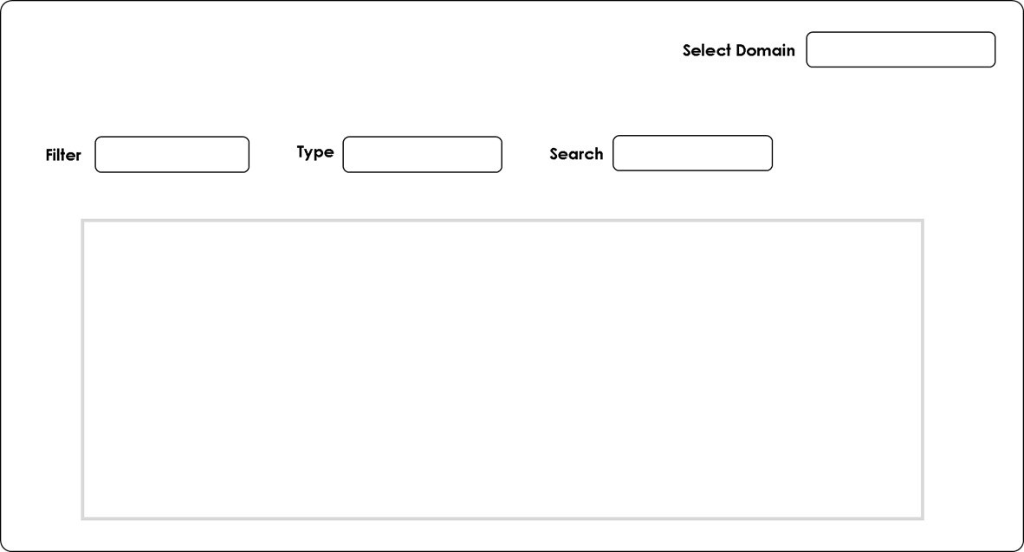

The goal of this project is to provide a search functionality for the neo4j database. With the selected domain selection and search value, we should be able to fetch that particular domain and mentioned search value node with its relationships and it should be displayed on the front end.

**Flowchart of Search functionality:**

On selection of domain in select domain dropdown gives the properties of selected domain in filter dropdown:

1. On selection of “BeneficialOwner” domain provides the following properties in the Filter dropdown :

Properties: 1. Name

2. Country_of_residence

3. Nationality

1. On selection of “Company” domain provides the following properties in the Filter dropdown:

Properties: 1. Name

2. Company number

1. On selection of “Address” domain provides the following properties in the Filter dropdown :

Properties: 1. Line1

2. Line2

3. Postcode

4. Country

1. On selection of “SICCode” domain provides the following properties in the Filter dropdown :

Properties: 1. Siccode

The screen shot of front end:

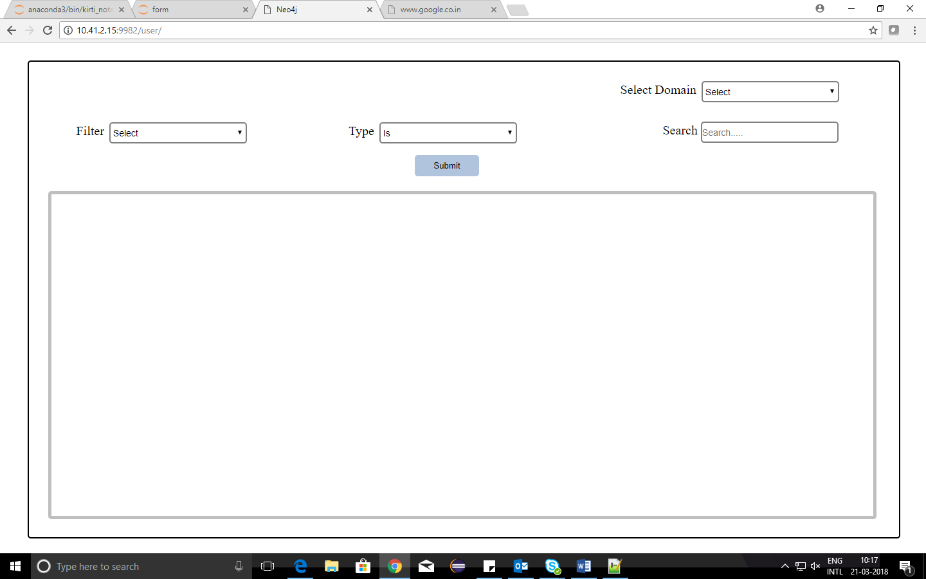

Type dropdown contains: 1. Is

2. Is not

3. Is one of

4. Exists

5. Does not exists

Search value is to enter value for the selected property.

**Working Procedure:**

1. To display a particular domain with relationships, Select the domain in the select domain dropdown and click on submit button. This will generate a query of below form.

"MATCH (n: domain)-[r]->(m) RETURN n as source_node,id(n) AS source_id,r, m AS target_node,id(m) AS target_id limit 20"

This generated query will be sent through a post request from python tornado to neo4j database using python code. Then by the fetching the required nodes and relationships data from neo4j database, the data can be represented in graph visualization form using vis.js.

For example, select a domain say, BeneficialOwner. This will generate a query like this:

"MATCH (n: BeneficialOwner)-[r]->(m) RETURN n as source_node,id(n) AS source_id,r, m AS target_node,id(m) AS target_id limit 20"

The graph visualization form for selected BeneficialOwner domain is as shown in below figure.

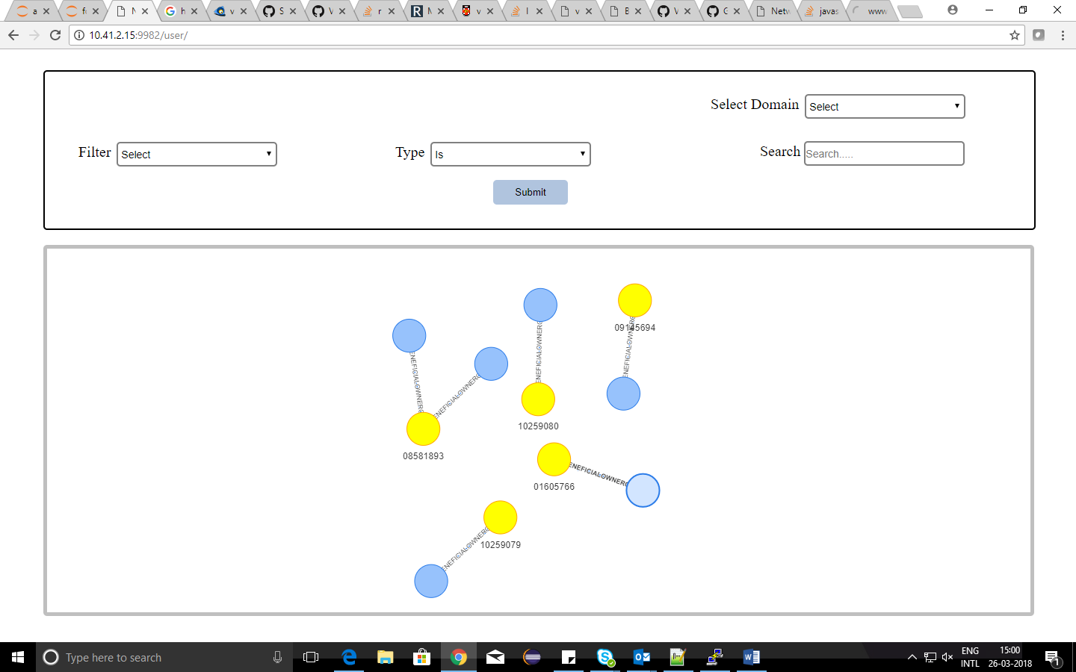

1. To display the graph of a particular node in a particular domain, then use the filter dropdown. First select a domain in select domain dropdown and then select a property of the selected domain in filter dropdown. Then enter the value of the property which has to be displayed. The generated query is of below form.

“MATCH (n)-[r]->(m) where n.property = search RETURN n as source_node,id(n) AS source_id,r, m AS target_node,id(m) AS target_id limit 20”

For example, select a domain say, Address .This will provides Address properties like Line1, Line2, postcode and country in filter dropdown. Now select a property say, country and enter search value i.e country name of Address say, ENGLAND. This would generate a query like this:

“MATCH (n)-[r]->(m) where n.country = ENGLAND RETURN n as source_node,id(n) AS source_id,r, m AS target_node,id(m) AS target_id limit 20”

The graph visualization form for selected Address domain with country name as ENGLAND is as shown in below figure.

